DSA 0601 - Data handling and visualization
Set 8 - Employee Performance Analysis

Name : B.Jahnavi
Reg.no:192325043

1.Line Chart of Performance
Program:

library(ggplot2)
employees <- data.frame(
Employee_ID = c(1, 2, 3),
Department = c("Sales", "HR", "Marketing"),
Years_of_Service = c(5, 3, 7),
Performance_Score = c(85, 92, 78)
)
ggplot(
employees,
aes(
x = Years_of_Service,
y = Performance_Score
)
) +
geom_line(linewidth = 1) +
geom_point(size = 3) +
labs(
title = "Employee Performance Trend",
x = "Years of Service",
y = "Performance Score"
) +
theme_minimal()
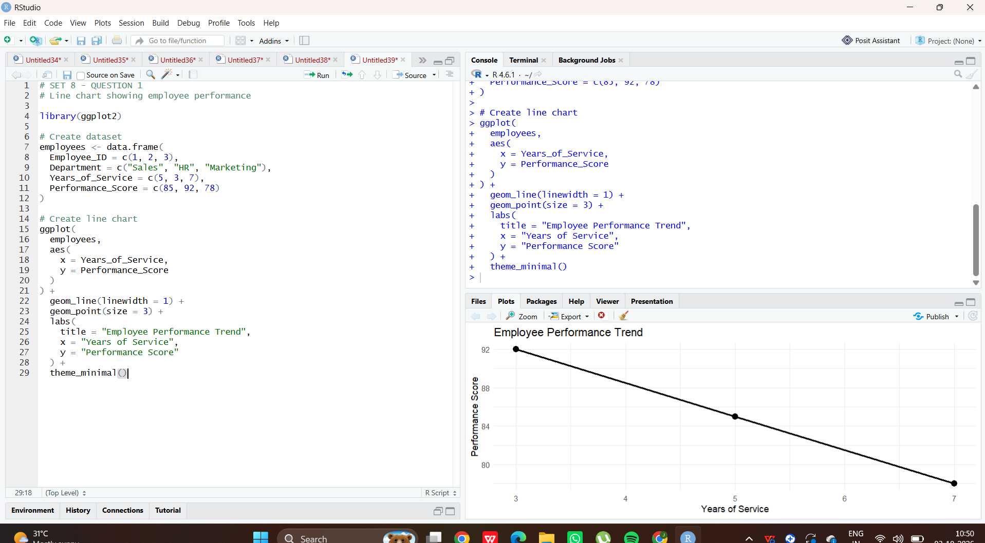

2.Bar Chart of Employees by Department
Program:

library(ggplot2)

# Create dataset
employees <- data.frame(
Employee_ID = c(1, 2, 3),
Department = c("Sales", "HR", "Marketing"),
Years_of_Service = c(5, 3, 7),
Performance_Score = c(85, 92, 78)
)

# Count employees in each department
department_count <- as.data.frame(
table(employees$Department)
)

colnames(department_count) <- c(
"Department",
"Number_of_Employees"
)

# Create bar chart
ggplot(
department_count,
aes(
x = Department,
y = Number_of_Employees
)
) +
geom_bar(
stat = "identity",
fill = "steelblue"
) +
labs(
title = "Employee Distribution by Department",
x = "Department",
y = "Number of Employees"
) +
theme_minimal()

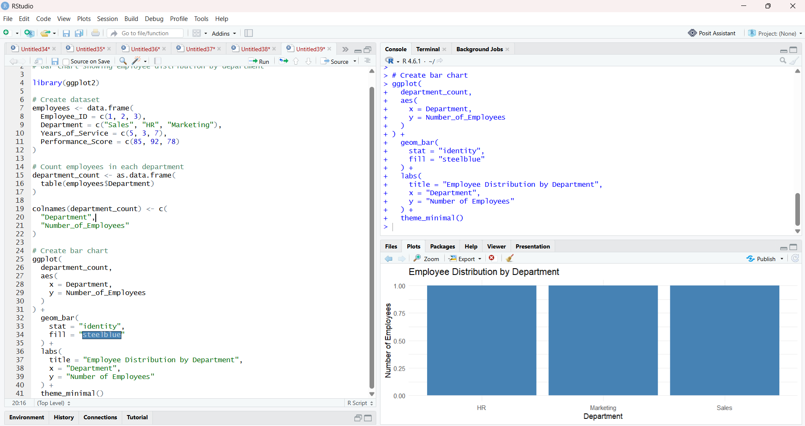

3. Employee Performance Table
Program:

employees <- data.frame(
Employee_ID = c(1, 2, 3),
Department = c("Sales", "HR", "Marketing"),
Years_of_Service = c(5, 3, 7),
Performance_Score = c(85, 92, 78)
)

# Display table
print("Employee Performance Table")
print(employees)

# Display formatted table
cat("\nEmployee Performance Data\n")
cat("--------------------------------\n")

for (i in 1:nrow(employees)) {
cat(
"Employee ID:", employees$Employee_ID[i],
"| Department:", employees$Department[i],
"| Years of Service:", employees$Years_of_Service[i],
"| Performance Score:", employees$Performance_Score[i],
"\n"
)
}

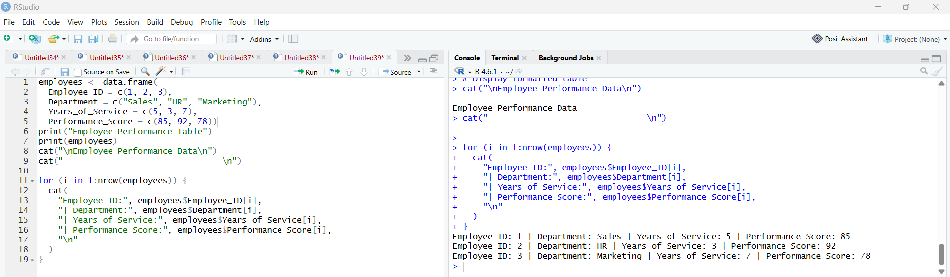

4.Tableau Dashboard
Program:

employees <- data.frame(
Employee_ID = c(1, 2, 3),
Department = c("Sales", "HR", "Marketing"),
Years_of_Service = c(5, 3, 7),
Performance_Score = c(85, 92, 78)
)

# Export CSV
write.csv(
employees,
"Employee_Performance.csv",
row.names = FALSE
)

print("Employee_Performance.csv created successfully!")

